Thalia L. Guadalupe

Rhonda Forbes

Software Engineering

11/21/2018

**Status Report**

**From the Team... [Two Points Each]**

1. Roles & Deliverables
   1. **Team Members:** Explain how delegation of objectives and goals is progressing? Have members fulfilled the initial roles and responsibilities assigned? Have any changes to roles or assignments been made?

**Rhonda roles:** Yes, I fulfilled my initial roles and responsibilities in the View as well in planning the database table design with Thalia.

**Thalia roles:**Yes, I fulfilled my initial roles and responsibilities in the model, controller as well in planning the database table design with Rhonda.

No changes to roles.

* 1. **Milestones:** – Describe whether the first iteration of objectives and goals have been completed as planned? Have adjustments to milestones been made since the last formal presentation to stakeholders?
     1. We finished with our 1st Milestone which was planning the database schema and the mock up of the website. We recently accomplished getting the login and add user page working with the database which is our 2nd milestone.
     2. Currently, we are planning our next step of what should the cafeteria workers see in the admin home screen page, as well as the other upcoming pages and ideas of how foods will be displayed, and edited, etc.
  2. **Requirements:** – Does the team record basic requirements and design engineering criteria? Does the documentation logged by the team reflect the specifics above? Remember - If it wasn’t documented, it didn’t happen.
     1. Definitely, each member upload daily to the group project on github. Each git push allow the user to comment what they add/change to the project to help the other members understand where the project stands.

**From Each Person... [One Point Each]**

1. **Prototype Purpose:** Explain the primary purpose of the prototype reported in the status report.

**Rhonda purpose:**

The purpose of the prototype was to show the view of the website. It displays the layout of the welcome page, and the registration and sign in page for the cafeteria workers. The purpose was also to show the database tables.

**Thalia purpose:**

The primary purpose of my roles is to provide the backend which saves and displays user information from the database, as well as create sql script and plan database table with group members. Without interaction with the backend to database the frontend will just be a skeleton.

1. **Prototype Context: -** Provide a brief description of where this prototype is used relative to the solution as a whole.

**Rhonda purpose:**

The current prototype features navigation links to other pages in the website, like the home page, sign in page, or wherever else the user decides to click on, they’ll be able to navigate to that page.

**Thalia purpose:**

The current prototypes’ backend is to store user information and display user first name, campus location and their status once they are logged in.

4. **Prototype Functionality**

1. **Format:**  – The prototype *must* appear in a manner that is similar to what a user would experience when operating the module, feature, or function.

**Rhonda purpose:**

The first page that shows is the welcome page for all users. The welcome page has graphics and a top and bottom navigation bar to other pages. Users are able to go to other pages using the navigation bars, and will see the design lay out of those pages.

**Thalia purpose:**

The current purpose of my part was to show that the user information is stored from View to the backend then to the database. User won’t see the interaction with the backend instead they will only see the front-end. Furthermore, displaying the information to model then passing it to the controller which will be displayed from the View that was stored from the database.

1. **Process:**  – The prototype demo must be similar to the intended steps followed in a user interface or can be the ordered steps of a storyboard as a user works with the prototype.

**Rhonda purpose:**

Users can go to other pages via the links.

**Thalia purpose:**

Currently the user will have their information stored and displayed for when they are login.

1. **Performance:** – Use of the prototype must clearly reflect the actions that result when a user engages the production feature. (The output or a screen shot is sufficient.)

**Rhonda purpose:** 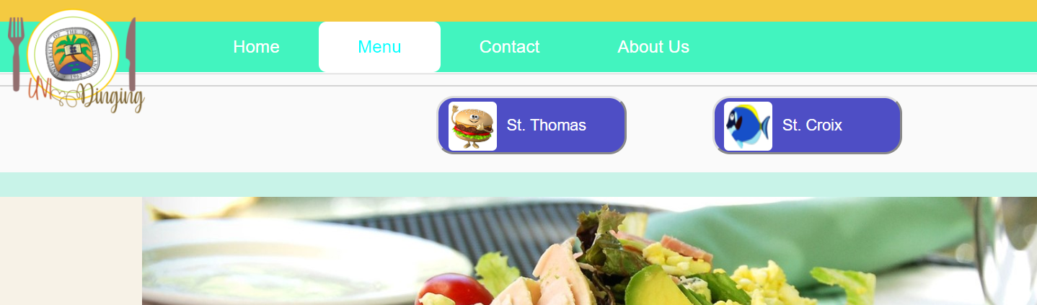

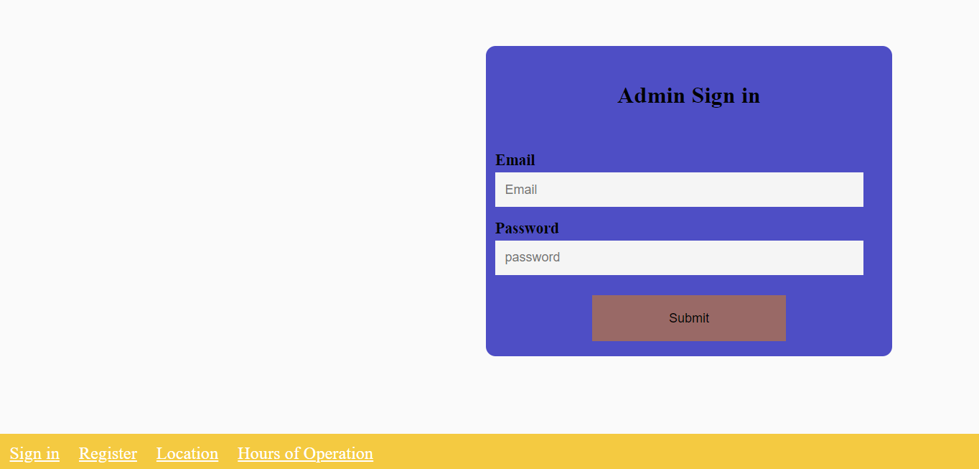

**Thalia purpose:**

Yes.

**Model:**

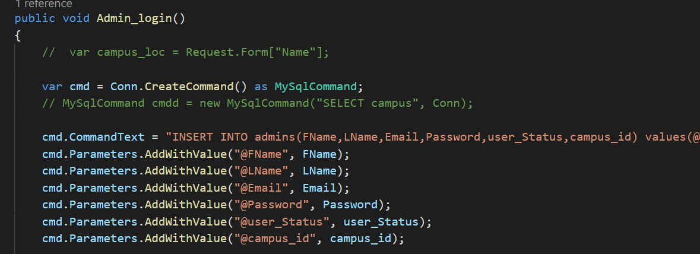

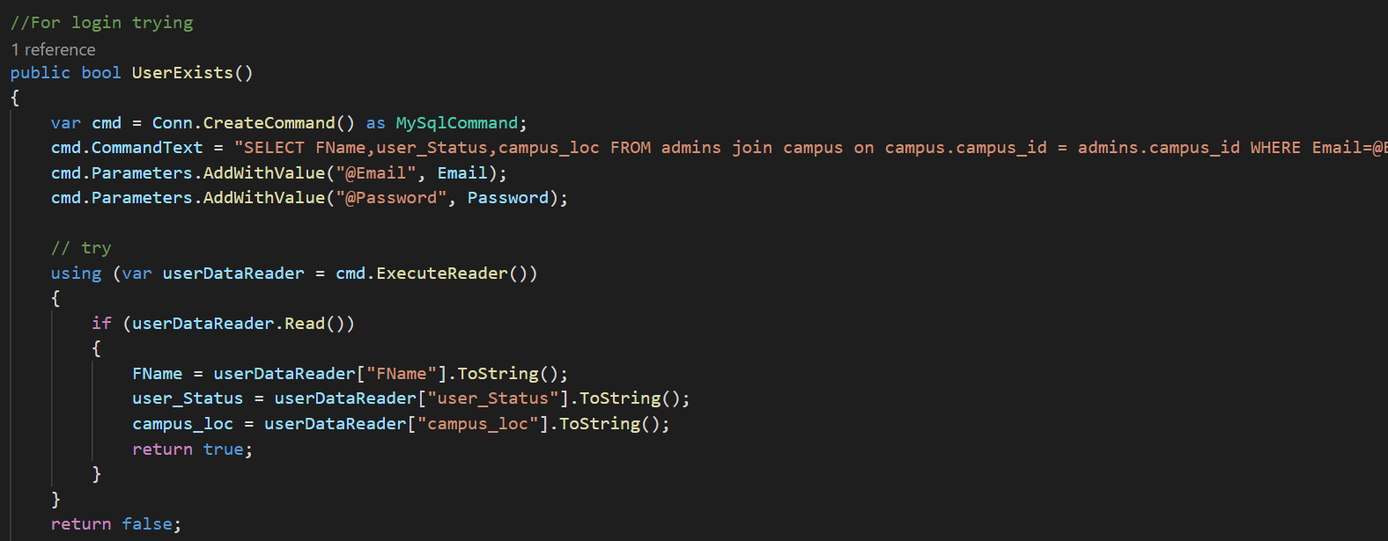

**Controller:**

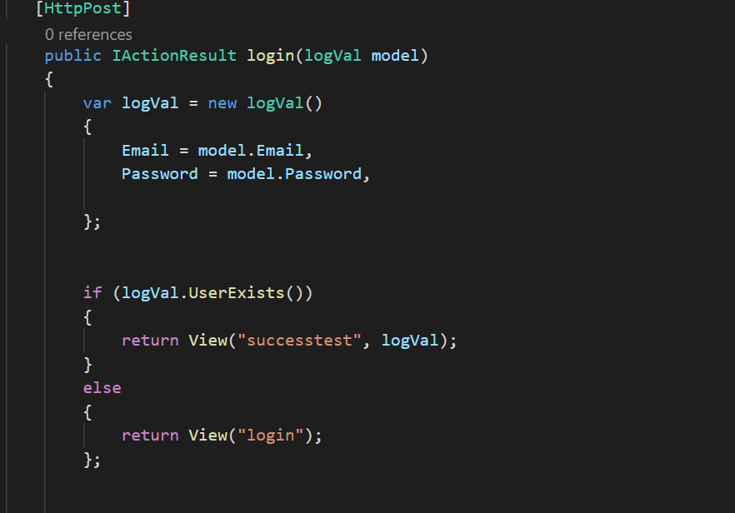

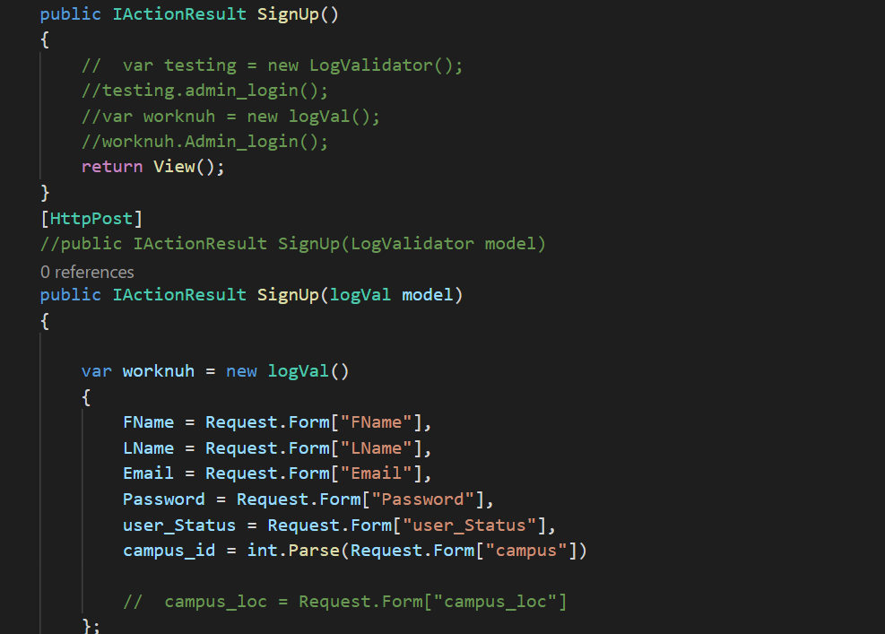

**Workbench:**

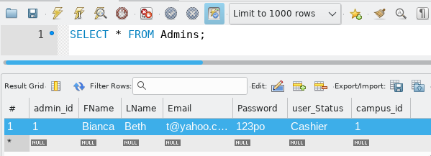

5. Interim Work: – List the important accomplishments that you have you accomplished since the last presentation/report.

**Rhonda:**

* Created the design of the database tables with Thalia
* Designed the layout for the welcome, sign up, and registration page
* Created basic layout for other pages linked
* Created forms for registration and sign up page.
* Designed slideshow for welcome page

**Thalia:**

* Completed how the database will be in the excel sheet with Rhonda.
* Write mysql script for workbench.
* Successfully connected mysql with a connection string from visual studio.
* Successfully got the project to insert Workers information to the database.
* Successfully got the project to read in data and check if the user exist for the login.
* Successfully read data from database and display user name, status and campus after they login.

6. Steps Performed for the Live Demo: o – Define the actions in order that you performed while you demonstrated the working prototype in the status report session. Did you run to generate a working user interface? Did you display of a wireframe representation of a user interface? Share a graphical representation or mockup of a prototype?

**Rhonda:**

* Database tables were shown
* Visual Studio was used to open the website
* Website opened on Chrome to show welcome page
* Showed slideshow feature on welcome page
* Showed that the website can navigate to other pages
* Showed the sign up page and the form
* Showed the registration page and the form

**Thalia:**

* Showed database tables from google sheet
* Showed SQL script in workbench.
* Ran Project to show that the user information is inserted into database.
* Demonstrated that the user information is displayed once they are logged in.

7. Issues, Challenges:s – Describe issues and challenges you personally encountered during this period; how you documented this and/or related this to your team. [Hint: A screenshot of an appropriate GitHub post would suffice.]

As a group, Rhonda and I decided to use the Issue tab to display issue we have encountered and if solve we close the issue.

**Rhonda:**

**Group work: Planning Database:**

**Link:** [**https://github.com/tguadalupe/UVI-Dining/issues/5**](https://github.com/tguadalupe/UVI-Dining/issues/5)

**View issues:**

**Link:** [**https://github.com/tguadalupe/UVI-Dining/issues/3**](https://github.com/tguadalupe/UVI-Dining/issues/3)

**Index view issue:**

**Link:** [**https://github.com/tguadalupe/UVI-Dining/issues/4**](https://github.com/tguadalupe/UVI-Dining/issues/4)

**Thalia:**

**Group work: Planning Database:**

**Link:** [**https://github.com/tguadalupe/UVI-Dining/issues/5**](https://github.com/tguadalupe/UVI-Dining/issues/5)

**Sign Up Issue: An unhandled exception occurred while processing the request:**

**Link:** [**https://github.com/tguadalupe/UVI-Dining/issues/2**](https://github.com/tguadalupe/UVI-Dining/issues/2)

**Issue with login:**

**Link:** [**https://github.com/tguadalupe/UVI-Dining/issues/1**](https://github.com/tguadalupe/UVI-Dining/issues/1)

8. Assistance, Guidance: – Did members of your team or course instructor(s) assist with guidance? If so, how did you capture this and disseminate this detail? [Hint: A screen shot of an appropriate GitHub post would suffice.]

**Rhonda:**

Thalia asked to see code for view so she could assist.

**Link:** [**https://github.com/tguadalupe/UVI-Dining/issues/2**](https://github.com/tguadalupe/UVI-Dining/issues/2)

**Thalia:**

Rhonda gives me suggestion on my Sign Up(add user) issue with the campus crying about no values.

**For more details please see the discussion Sign up Issue github form:**

**Link:** [**https://github.com/tguadalupe/UVI-Dining/issues/2**](https://github.com/tguadalupe/UVI-Dining/issues/2)